* Please find attached postman collection for testing



* Please find executable jar and command to run service

Run this command in command promt “java -jar cgi_test-0.0.1-SNAPSHOT.jar”



* API documentation, I have implemented swagger in my spring boot service. Please hit the below link to view swagger documentation.

<http://localhost:8080/swagger-ui.html>

Please refer below screen shot.

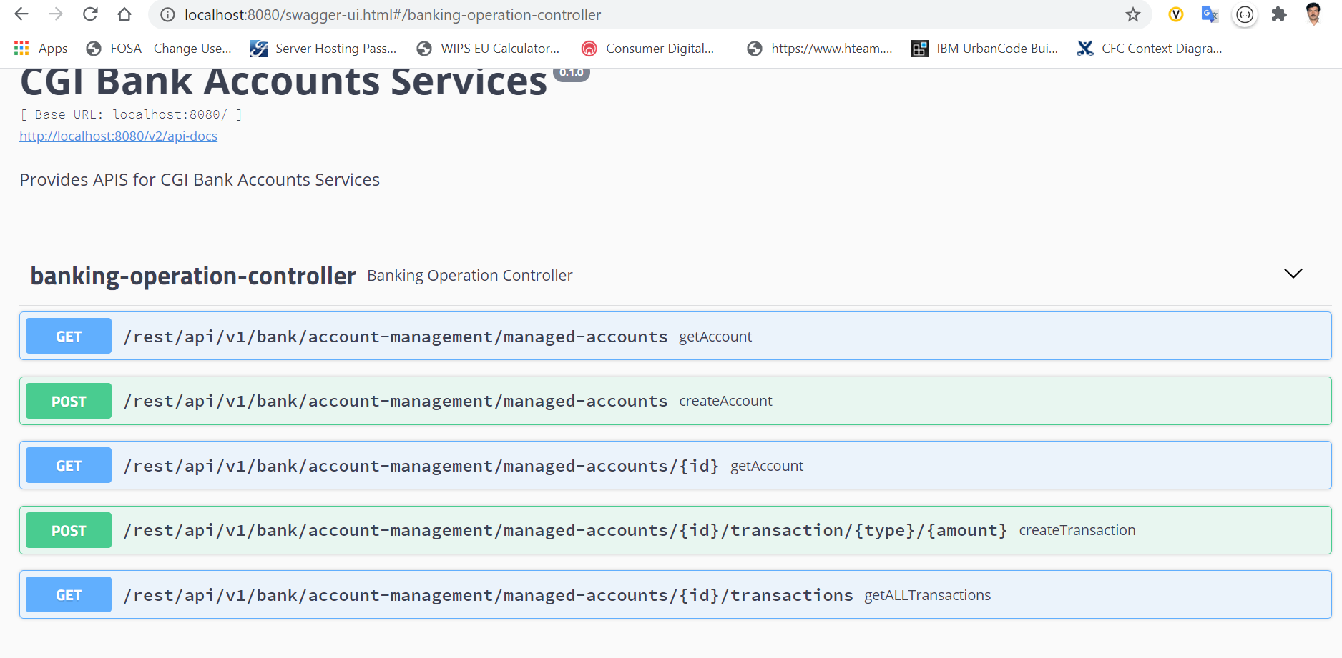

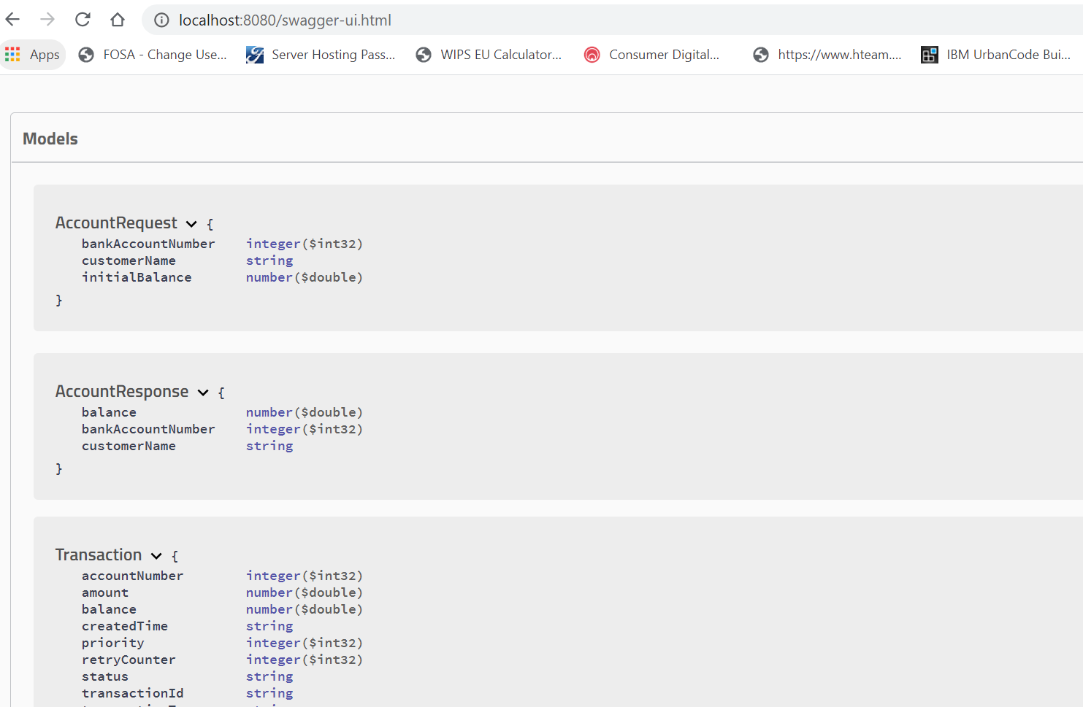

* Please refer below screenshot for test coverage and testcase results

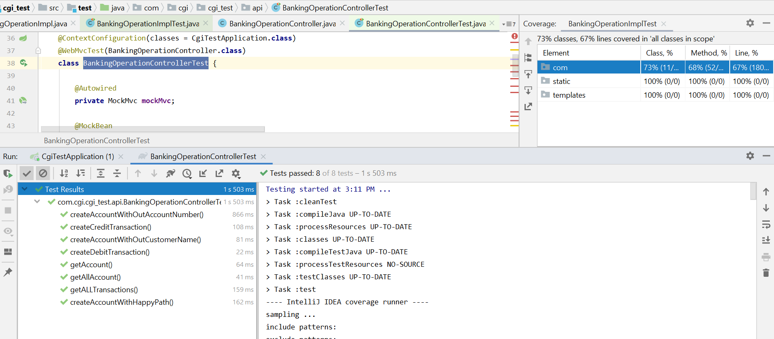

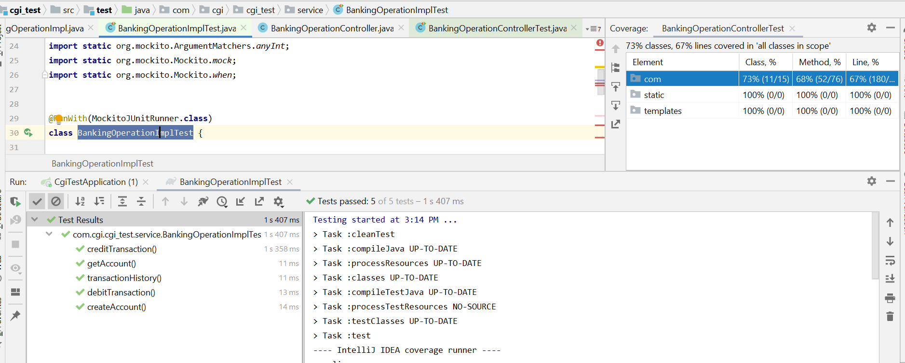

Please refer below postman screenshots for your reference

1. Create Account

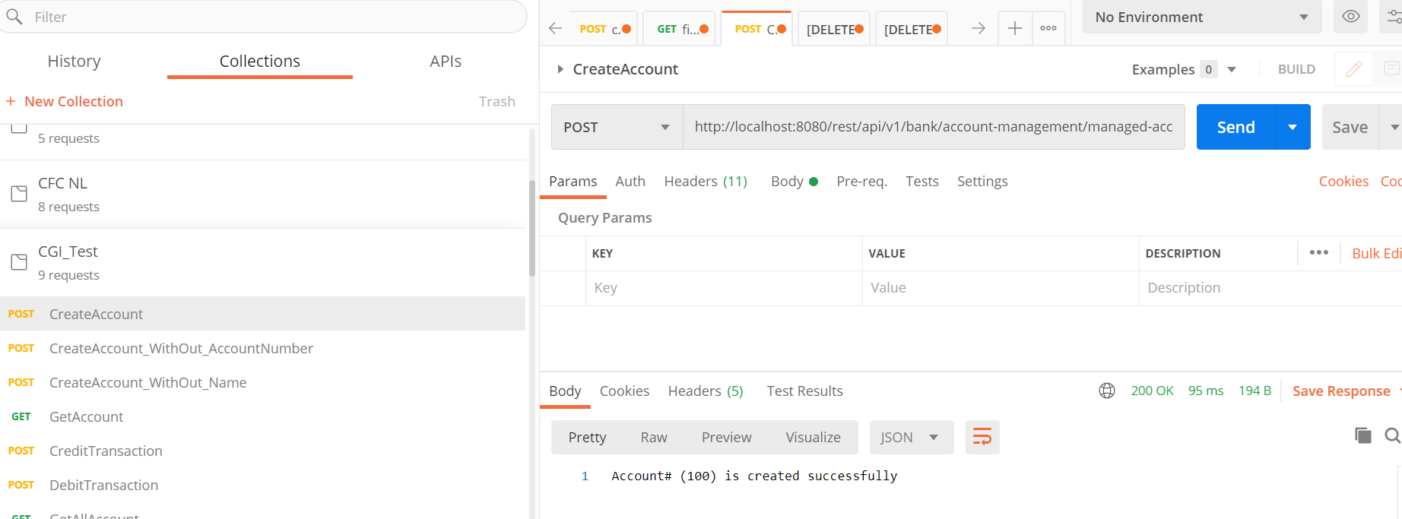

1. Create Account Without Account#

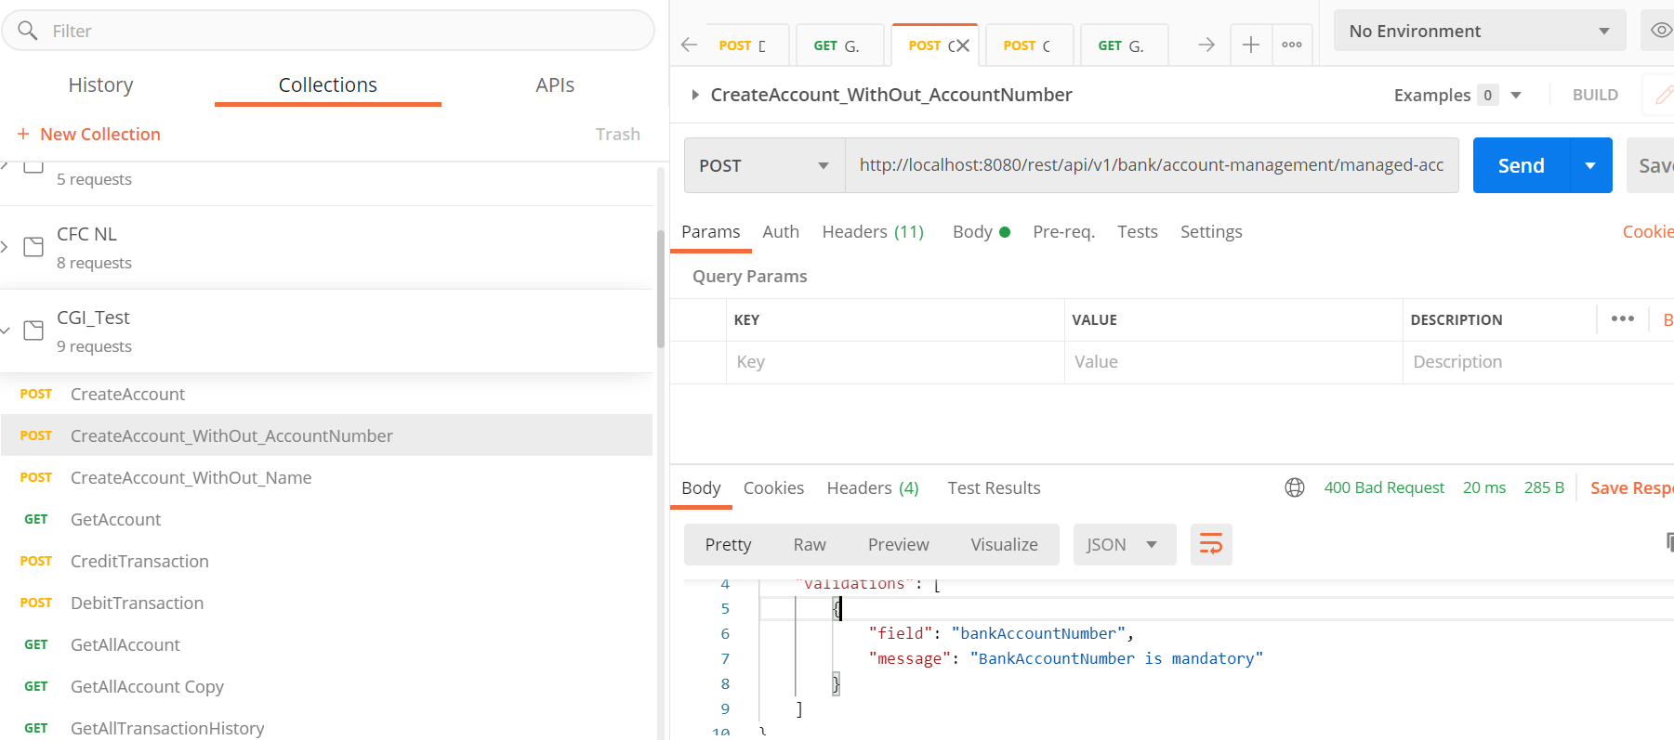

1. Get Account with Account No (<http://localhost:8080/rest/api/v1/bank/account-management/managed-accounts/1000>)

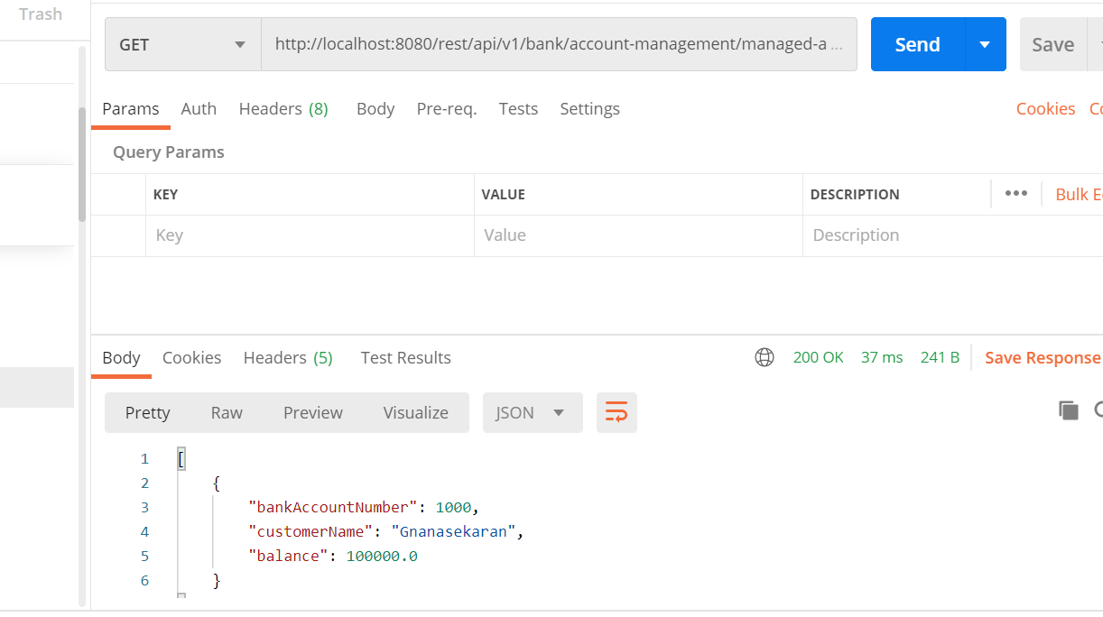

4 Get All accounts (<http://localhost:8080/rest/api/v1/bank/account-management/managed-accounts/>)

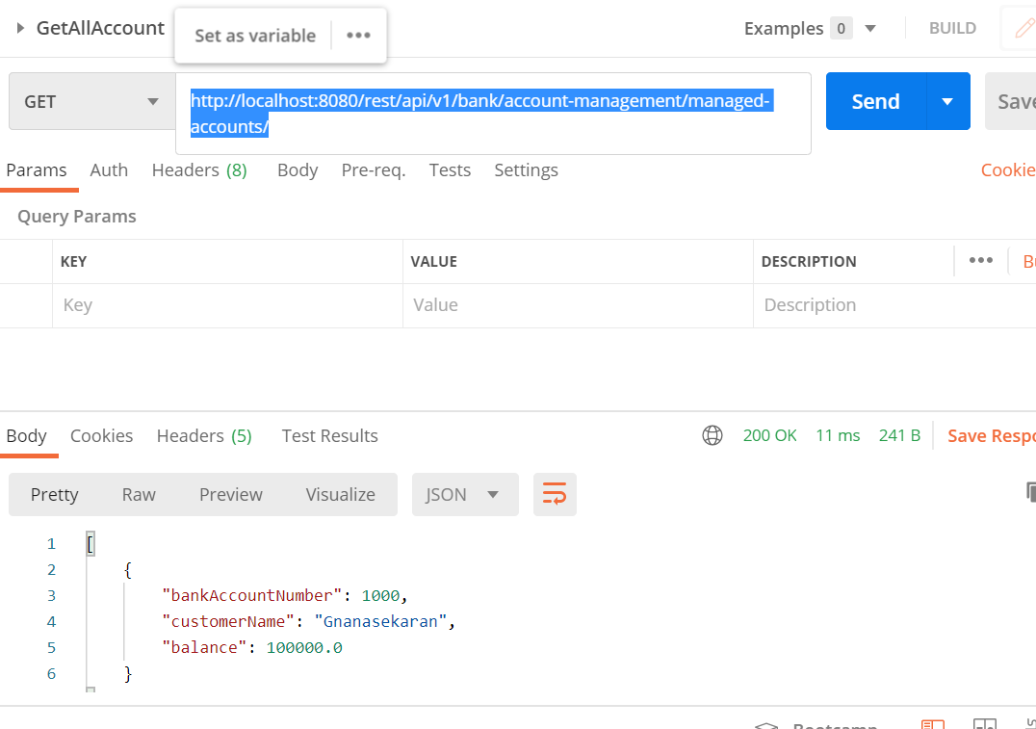

5 Credit Transaction (http://localhost:8080/rest/api/v1/bank/account-management/managed-accounts/100/transaction/credit/3000)

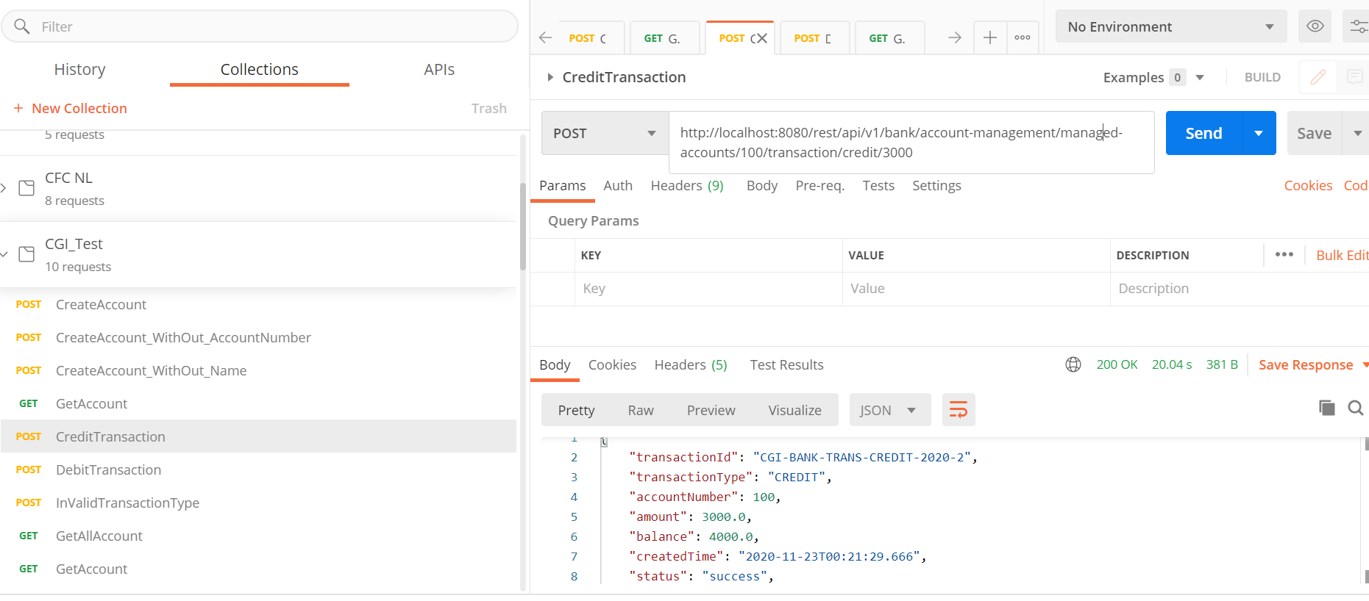

6 Debit transaction (http://localhost:8080/rest/api/v1/bank/account-management/managed-accounts/100/transaction/debit/100)

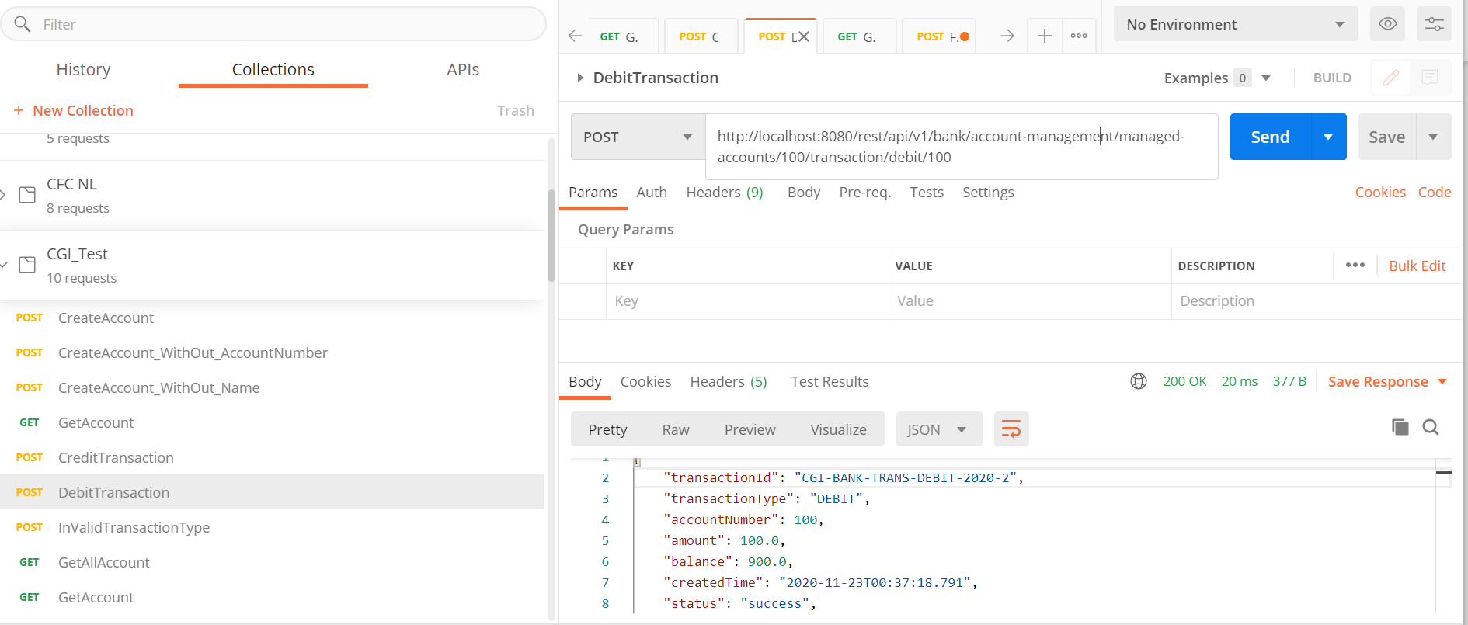

6 TransactionHistory (<http://localhost:8080/rest/api/v1/bank/account-management/managed-accounts/1000/transactions>)

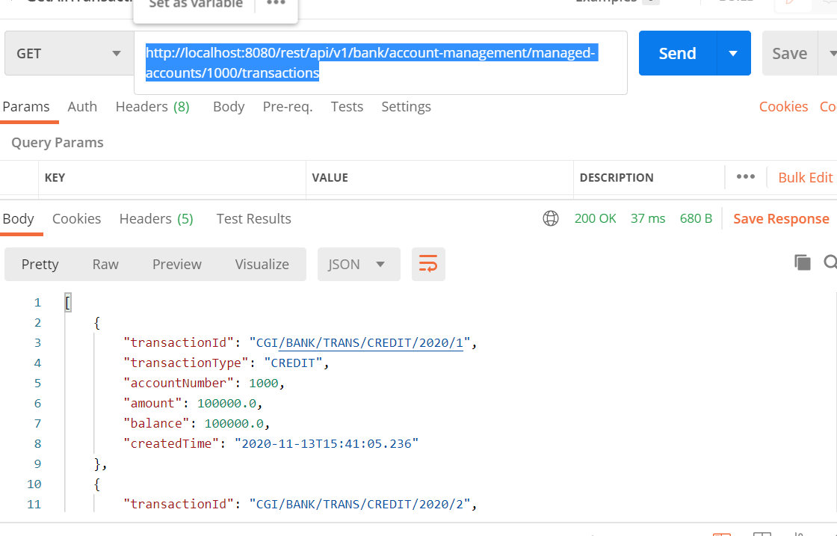

If any thread is locked bankAccount for credit/debit operation, other thread will wait upto 5 secs if lock is not released with in 5secs, it will assign transaction into priorityQueue with status “In Progress”.

PriorityQueue will be observed by Consumer, it will pickup transaction object and it will attempt for account updation upto maximum 3 attempt. If not succeeded then transaction will be marked as failed.

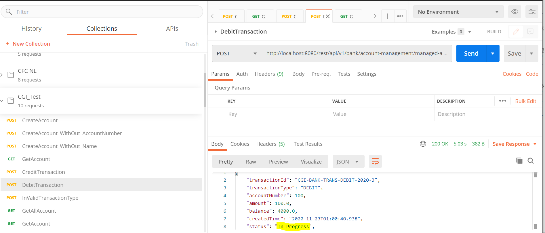

7 SpringBoot actuator is implemented for service health check management.